THEORETICAL CALCULATION OF POCKET BATTERY LIFE

1) Calculation of how much amps ESP draws on deep sleep for 10 minutes  
2 ) Calculation of how much amps drawn on kurals changed for 10 minutes  
3) arriving at an average amps drawn  
4) dividing the battery capacity (300 mAh) by this theoretical current average value (ma) and to find how many hours battery can last

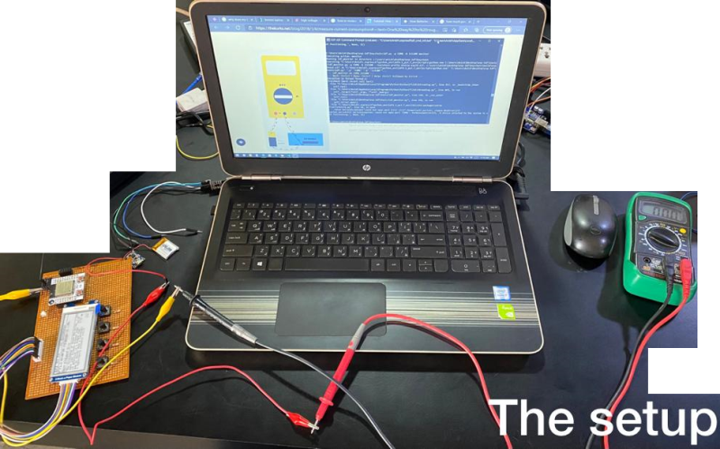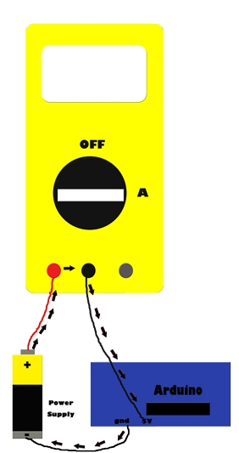The setup on the right was taken from a blog about how to measure current consumption and how important it is to measure battery life. Here is the link: [Tutorial: How to measure current consumption and why should you do it? — The Arduino Maker Man (thekurks.net)](https://thekurks.net/blog/2018/1/4/measure-current-consumption#:~:text=One%20way%20to%20roughly%20figure,power%20supply%20needs%20to%20be.) . Now this setup has been setup along with the laptop as well and tried to see how it performs along with a serial monitor but it did not work. So the case was switched back to just a battery setup. The positive of the multimenter was connected to the +ve of the battery. The –ve of the battery was connected to the +ve of the project and the –ve of the project to the negative of the multi-meter. Setting the mode to ammeter, the multi-meter was able to show the current consumption of when the project was On (active mode, reading kurals) or during Deep Sleep. The Calculation was done at 10 minutes each test and for the active mode (in order to simulate a timing as in an oscilloscope) the current drawn per kural was plotted along time in y axis. The calculations of the two are as follows:

1. Current drawn during deep sleep: 58.7 uA
2. Current drawn in active mode (avg.): 34.857 mA

Observations:

What we can infer from this is that an average of 58.7 micro amps was drawn by the project during deep sleep. And it was possible to switch 122 kurals in 10 minutes. During this active mode an average of 34.857 milli amps were drawn. The formula in the next page can be used to find out how many hours the device can operate. But since there are two modes in our project, it is a bit tricky to calculate the battery life.

122 Kurals

Now this is the formula to calculate the Battery Life:

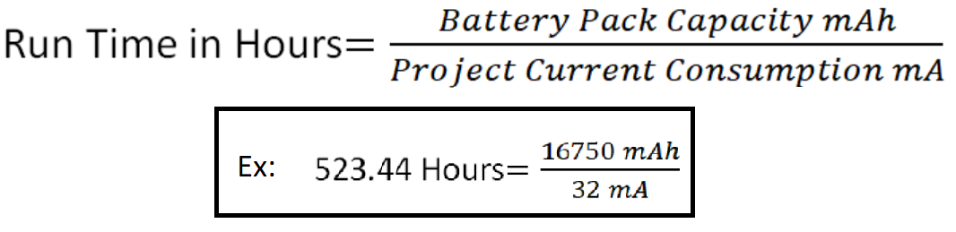

Assuming the user reads 122 kurals (or less) in 10 minutes (this need not necessarily be continuous, i.e the total run time of active mode per day is 10 minutes) and lets the remaining 23 hours & 50 minutes in deep sleep (again this need not be continuous).

There are ((23 X 6) + (1 X 5)) number of 10 minutes in 23h 50m.

OR there are 143 number of 10 minutes…

Thus an average current usage of the user with 1 (active mode) (10 min usage) & 143 (deep sleep) (10 min usages) would be in the following ratio:

1 X 10 minutes of active mode &

143 X 10 minutes of deep sleeps

Average current drawn per day = (1 X 34.857 X 10^3) + (143 X 58.7) micro amps

144

= 34857 + 8394.1 micro amps

144

= 300.355 micro amps

AGAIN, this calculation is not avg. current drawn per day, because current cannot be calculated like that, only power or energy can. Current is calculated averagely based on usage of the user per day. Now that we have an average current drawn on average usage basis, we can calculate total run time in hours:

Run time in hours = 300mah X 10^3

300.355

= 998.82 hours = 41.61 days.

Disclaimer:

1. This was calculated on an assumption that the user is an average user of the product and a total active button clicking usage of the product was only 10 minutes per day.
2. The user has only read 122 kurals per day. At this rate, the user can finish reading all the kurals by 2 weeks
3. No best case scenario or worst case scenario was implemented in this calculation (yet !!!)
4. This entire calculation has assumed that the user has never used Bluetooth functionality.
5. The current drawn during BT on/off/usage has not been calculated
6. The active mode current calculation was pretty cool & rigorous. Yes it was pretty smart. Just thought you should know that… coz boot draws more current, also reads a text from spiffs, then there’s a standby(during reading the kural) which also draws some power & these had to be averaged carefully to the third decimal which involved too much brain power.

Yet to do:

1. Add Battery Stress Tests information to this document.
2. Actually and practically see how long the product lasts.